Ideation Phase
Brainstorm & Idea Prioritization Template

Date | 18 june 2026
Team ID
Project Name | HOUSE RENT
Maximum Marks | 4 Marks

Brainstorm & Idea Prioritization Template:
Brainstorming is a creative problem-solving technique used to generate, evaluate, and prioritize ideas for developing an effective solution. During the planning phase of the HouseHunt project, various ideas and features were explored to identify the most practical and user-friendly functionalities for the application.
The brainstorming process helped in defining the project scope, selecting essential features, and prioritizing functionalities based on feasibility, user requirements, and project objectives. Several ideas such as property listing management, advanced property search and filtering, user authentication, property image galleries, wishlist functionality, and secure communication between buyers and sellers were discussed and evaluated.
This approach ensured that the final application focused on providing a seamless property-search experience, efficient property management, secure user authentication, and easy interaction between property owners and potential buyers or tenants. By carefully analyzing different possibilities and selecting the most impactful features, the HouseHunt platform was designed to simplify the process of finding, listing, and managing properties while enhancing overall user satisfaction.
Reference: https://www.mural.co/templates/brainstorm-and-idea-prioritization
Step-1: Problem Identification and Selection
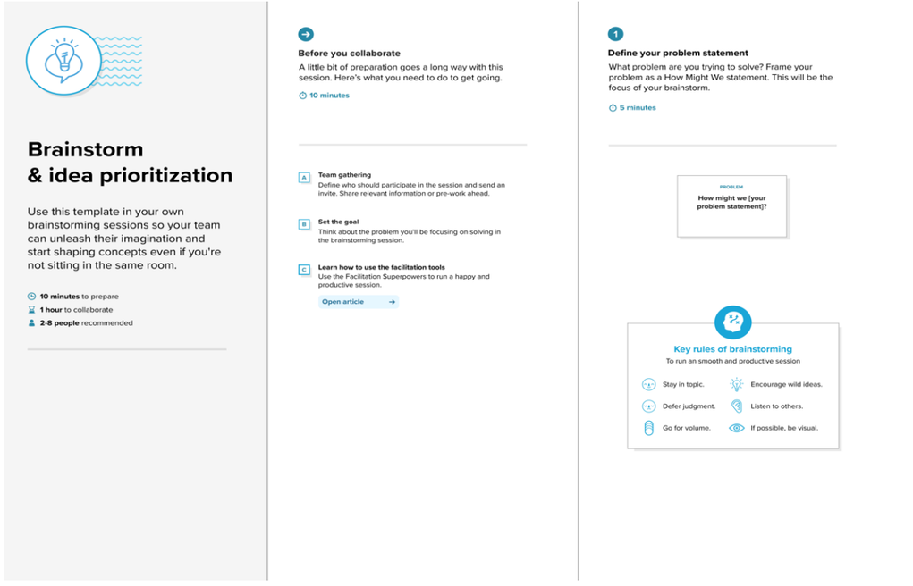
Problem Identification
The first step involved identifying a real-world problem and defining the project objective. The goal was to develop an online property management and house-search platform that simplifies the process of finding, listing, and managing residential properties. After analyzing user requirements and common challenges faced in traditional property searching, such as limited access to property information, difficulty in comparing listings, and inefficient communication between property owners and potential buyers or tenants, the problem statement was finalized.
Problem Statement
How can an online property management platform simplify the process of searching, buying, renting, and listing properties while providing efficient property management, user authentication, and communication features for users and property owners?
Step-2: Brainstorming and Idea Listing
During this phase, various ideas and features were identified and evaluated based on the project objectives. The focus was on creating a user-friendly property management platform while ensuring efficient management of property listings, users, and property inquiries.

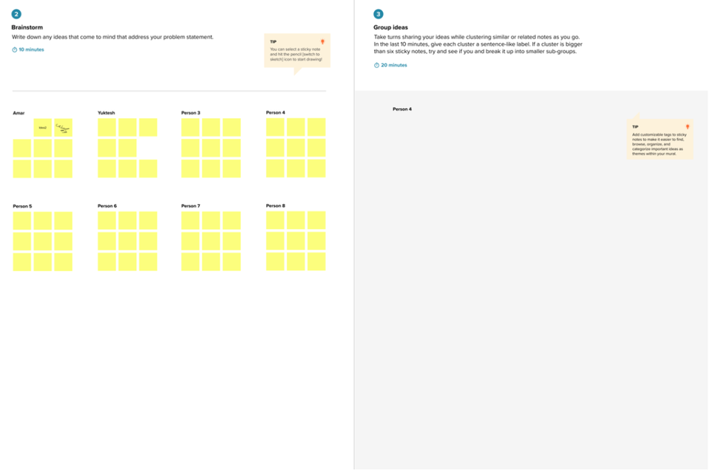
Ideas Generated:
- User Registration and Login
- Role-Based Access (User/Admin)
- Property Listing Management
- Property Search Functionality
- Property Filtering by Location, Price, and Type
- Property Details Page
- Property Image Gallery
- Add to Favorites/Wishlist
- Property Inquiry and Contact System
- User Profile Management
- Admin Dashboard
- Property Management
- User Management
- Inquiry Management
- Property Status Management (Available/Sold/Rented)
- MongoDB Database Integration
- JWT Authentication
- Responsive User Interface
- MERN Stack Architecture
These ideas were analyzed and organized into user-facing features, administrative features, and technical implementation requirements before moving to the prioritization stage. This process ensured that the HouseHunt application would provide a seamless property-search experience while maintaining efficient property and user management capabilities.

Step-3: Idea Prioritization
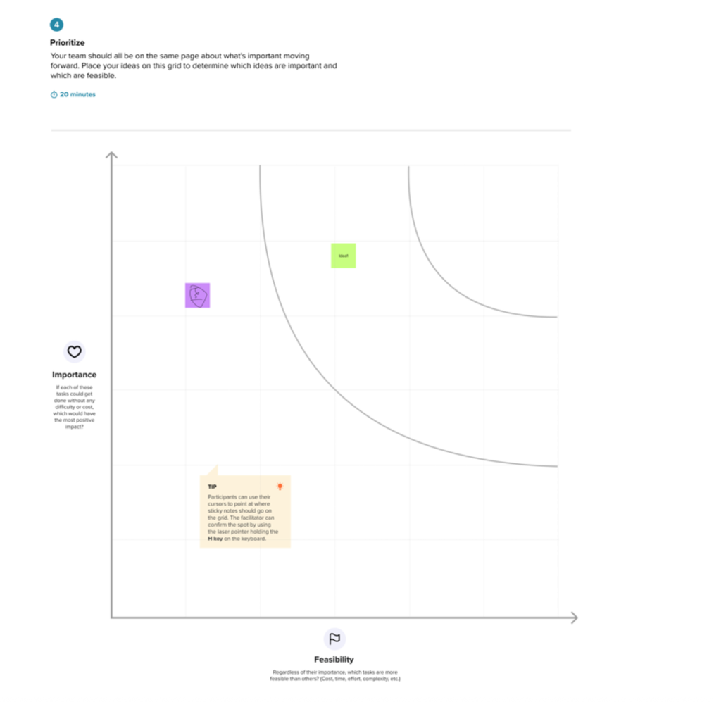

After generating and analyzing the various ideas, the features were prioritized based on their importance, feasibility, and impact on the overall user experience. Priority was given to the core functionalities required for a fully functional property management and house-search platform.
High Priority Features
- User Registration and Login
- Property Listing Management
- Property Search and Filtering
- Property Details Page
- Property Image Gallery
- Property Inquiry System
- User Profile Management
- Admin Dashboard
- Property Management
- User Management
- Inquiry Management
- Property Status Management (Available/Sold/Rented)
Medium Priority Features
- Favorite Properties (Wishlist)
- Advanced Search Filters
- Property Categorization (Apartment, Villa, Independent House, etc.)
- Recently Added Properties
- Location-Based Property Browsing
Future Enhancements
- Property Reviews and Ratings
- Virtual Property Tours
- Online Property Booking
- Email Notifications
- Property Recommendations
- Interactive Maps Integration
- Property Price Analytics
- Chat System Between Users and Property Owners
Based on this prioritization process, the high-priority features were selected for implementation in the HouseHunt application to ensure a complete and efficient property-search experience for users, property owners, and administrators. The selected features provide the essential functionality required for property listing, searching, management, and communication, while maintaining a user-friendly and scalable platform.

